Resource Group
What is a Resource Group
A Resource Group in Azure is like a folder that holds all the resources (services) related to a project or app.
For example:
If you build a website, you might have:
- A Virtual Machine (VM) for the web server
- A Storage Account for images
- A Database for user data
You can put all of these inside one Resource Group — making it easier to manage, monitor, and delete them together.

Create a Resource Group
→ Sign in to the Azure Portal
→ In the search menu, search for Resource groups.
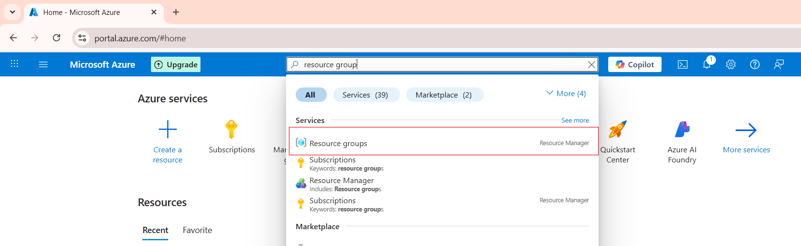

Click on the resource group and click on the create button.
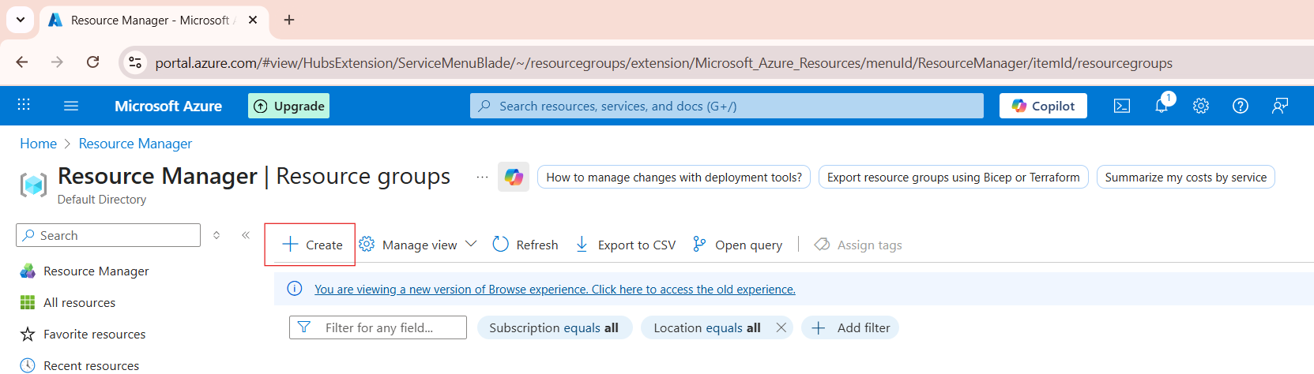

After clicking the Create button, we can see the Resource group section. We should provide the resource group name and then click the Next button.

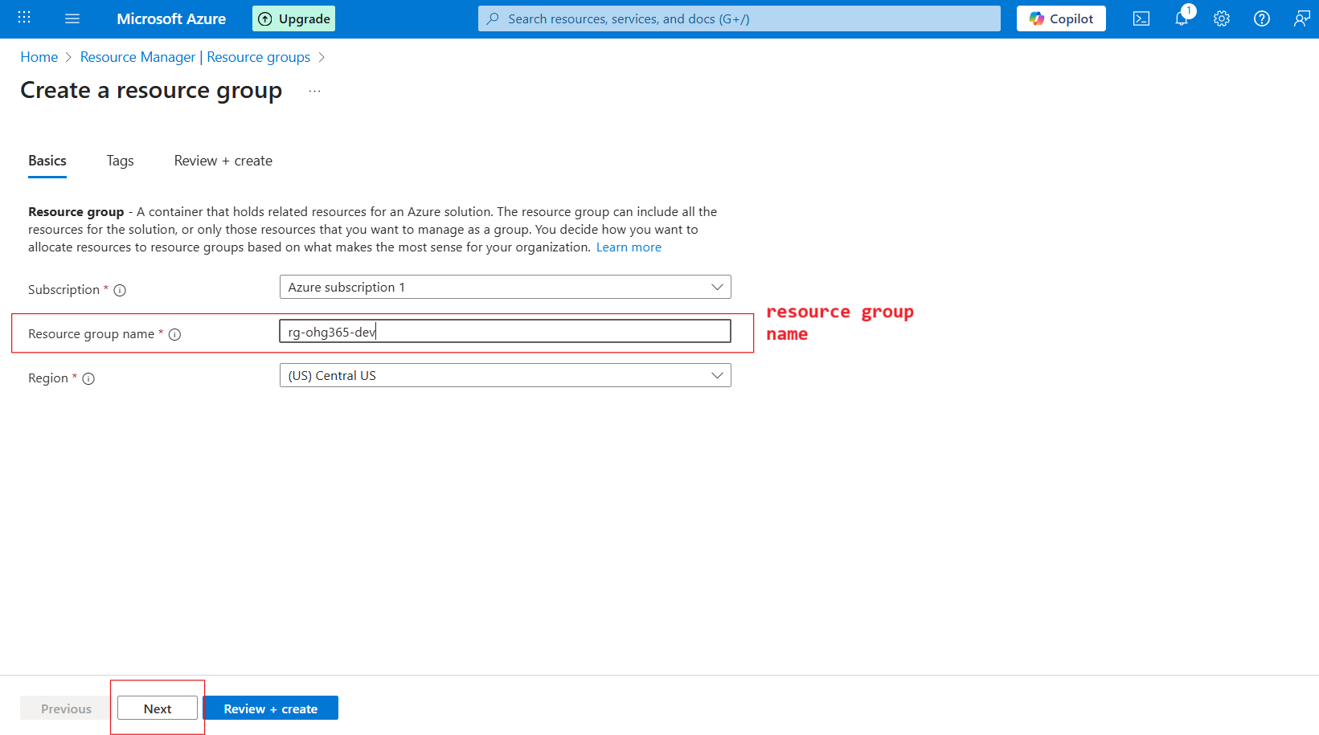

After clicking the Next button, we can view the Resource groups. In the Resource groups section, there is a Tags option. Click on the Tags option and select the required options. Then click the Review + Create button.

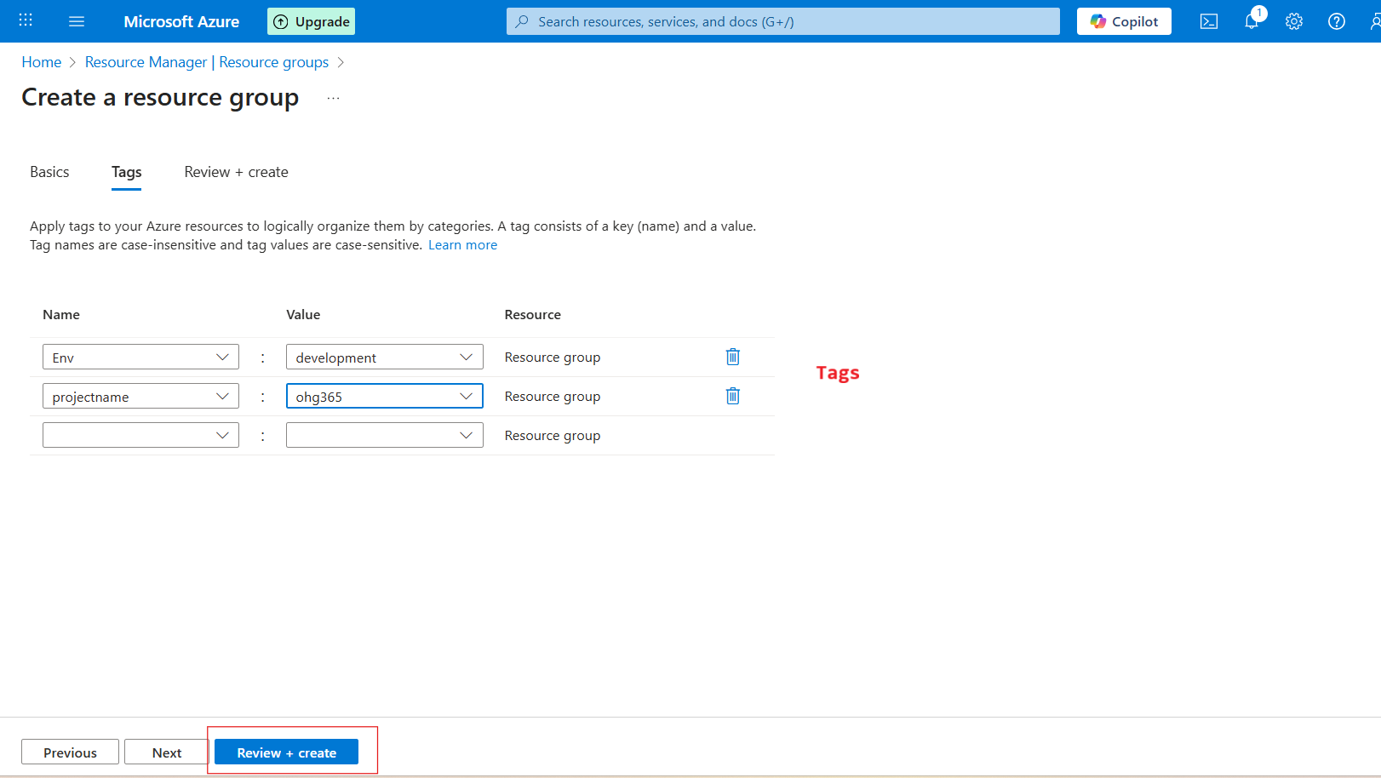

After clicking the Review & Create button, we will be taken to the Review + Create page. Verify the details, and then click the Create button.
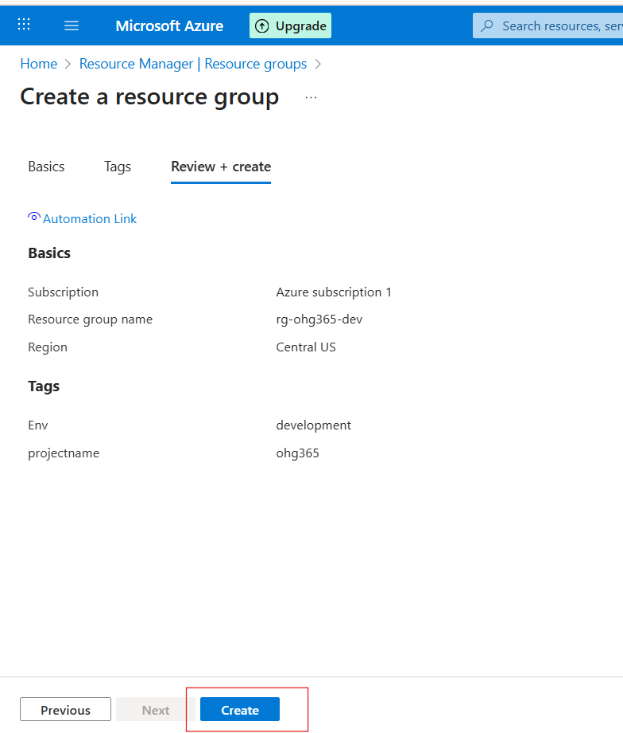

After clicking the Create button, we can see the resource group. In that resource group, we are able to view the list of resource groups in the Resource Manager.
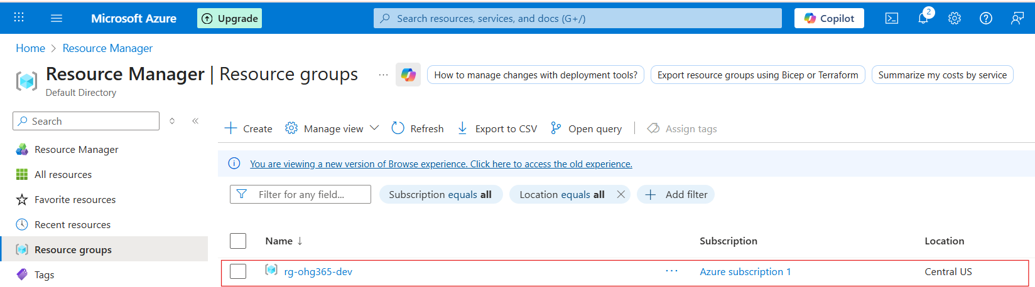

Overview of resource group:
Name: rg-ohg365-dev → This is your Resource Group’s name.Usually, names include clues about the project or environment:
- rg = Resource Group
- ohg365 = Project or team name
- dev = Environment (like dev, test, or prod)
Buttons:
Create: Add new Azure resources (like VMs, storage, databases).
Manage view: Customize how your resources list looks.
Delete resource group: Deletes the entire group and all its resources (be careful!).
Refresh: Updates the view if new resources were added.
Export to CSV: Export your resource details (helpful for reports).
Open query: Create or run custom filters using Azure Resource Graph.

